Author: Matthew Eagleman
Date Created: 2/2/2026
Project Artifacts
Add A* pathfinding to project (Matthew)
Description:
Find an A* pathfinding package that we can import into our project, and set it up.
Notes:
- Look for specifically unity 2d
- You can make a new branch to test out different algorithms

Implement Inventory System
Description:
Make it so that the player can pick up items, Organize them in his inventory, and Equip items
Notes:

Model Dialogue System (Owen)
Description:
Create a model of the dialogue system, and its interconnecting parts.
Notes:
- We will use the lucid chart
- You should be able to interact with people, and make commentary on objects around the space.
- You should be able to talk to multiple people at the same time
- There should be a space for a profile to convey emotion and such
- There should be a space for the name of the person speaking
- This will be a tool for us to create conversations
- You will be using Unity’s built in UI functionality
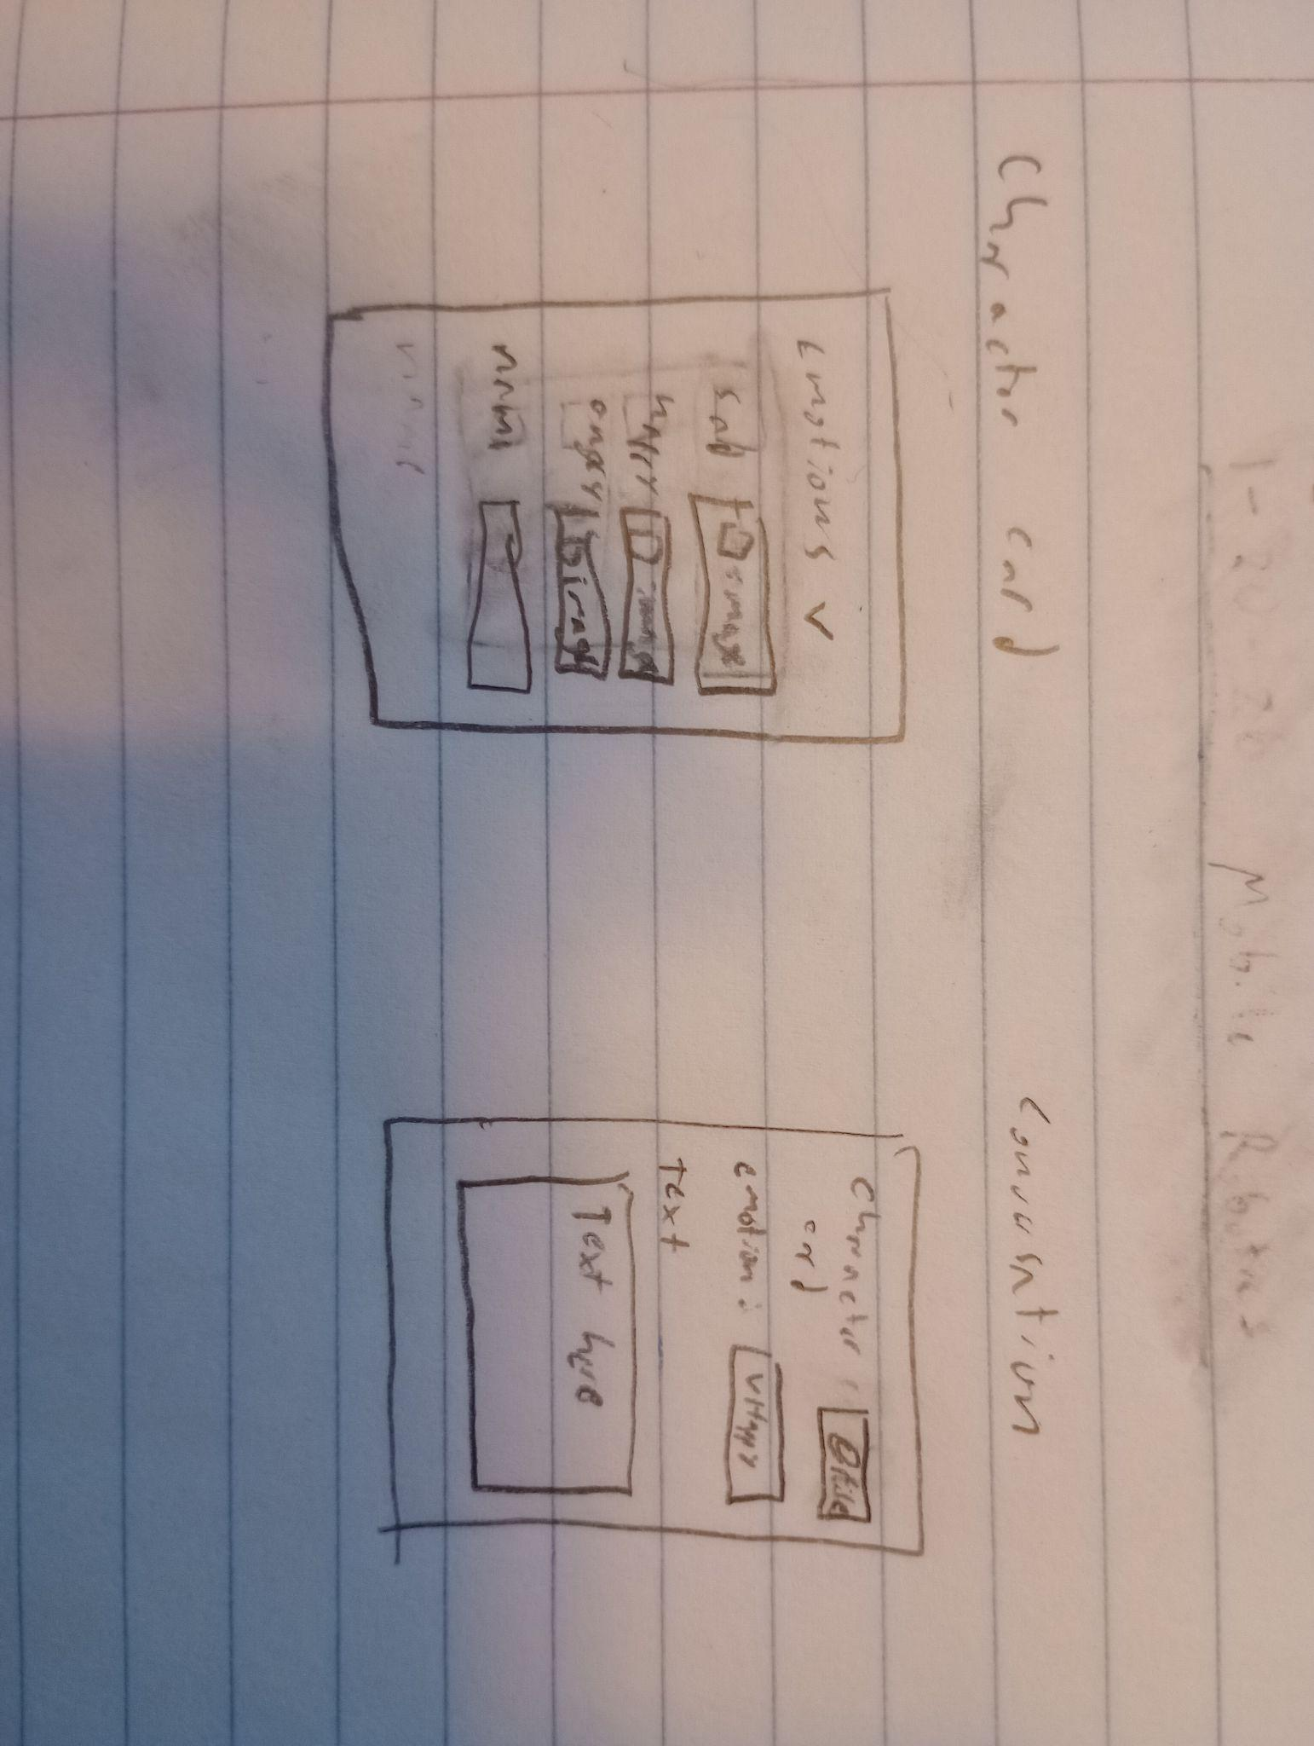
Add Camera Follow (Trevor)
Description:
Make it so the camera smoothly follows the player
Notes:
- We will use cinemachine for this, I’d recommend just watching a tutorial video
- There is a weird glitch where the player kinda shakes as he’s walking when the camera follows him. I think it has something to do with the graphics being pixel perfect, and have yet to figure out a solution, but it looks bad and I don’t like it.
- Experiment and come up with a few options that look good

Add stair functionality
Description:
When the player is on the stairs It should look like he is walking up the stairs
Notes:
- There’s already a space for it in the movement section, but it's old and bad. You can delete that once you implement the new version
- I’d recommend using Physics2d.OverlapPoint() to check if the point at the player's feet is within the stairs.
- You can use a layermask with OverlapPoint() to only detect the stairs layer. The stairs will have to be on the layer marked stairs
- OverlapPointAPI: https://docs.unity3d.com/6000.3/Documentation/ScriptReference/Physics2D.OverlapPoint.html
- I’ve never used that OverlapPoint thing but it seems better than raycasting.
- It would be nice if you could find a way to check for stairs without doing it every frame.

Create kitchen assets
Description:
Create art for the game. Here’s what we know we need so far:
- Fridge
  - Fridge decorations (pictures, magnets, etc.)
- Table
- Chair for table. We will flip it to create 2
- Center island
  - Sink
- Counter
  - Oven/Stove
- Upper cabinets
  - Microwave
- Potted plant
- Knife set
- Fruit basket
- Candles
- Knife
- Cutting board
Notes:
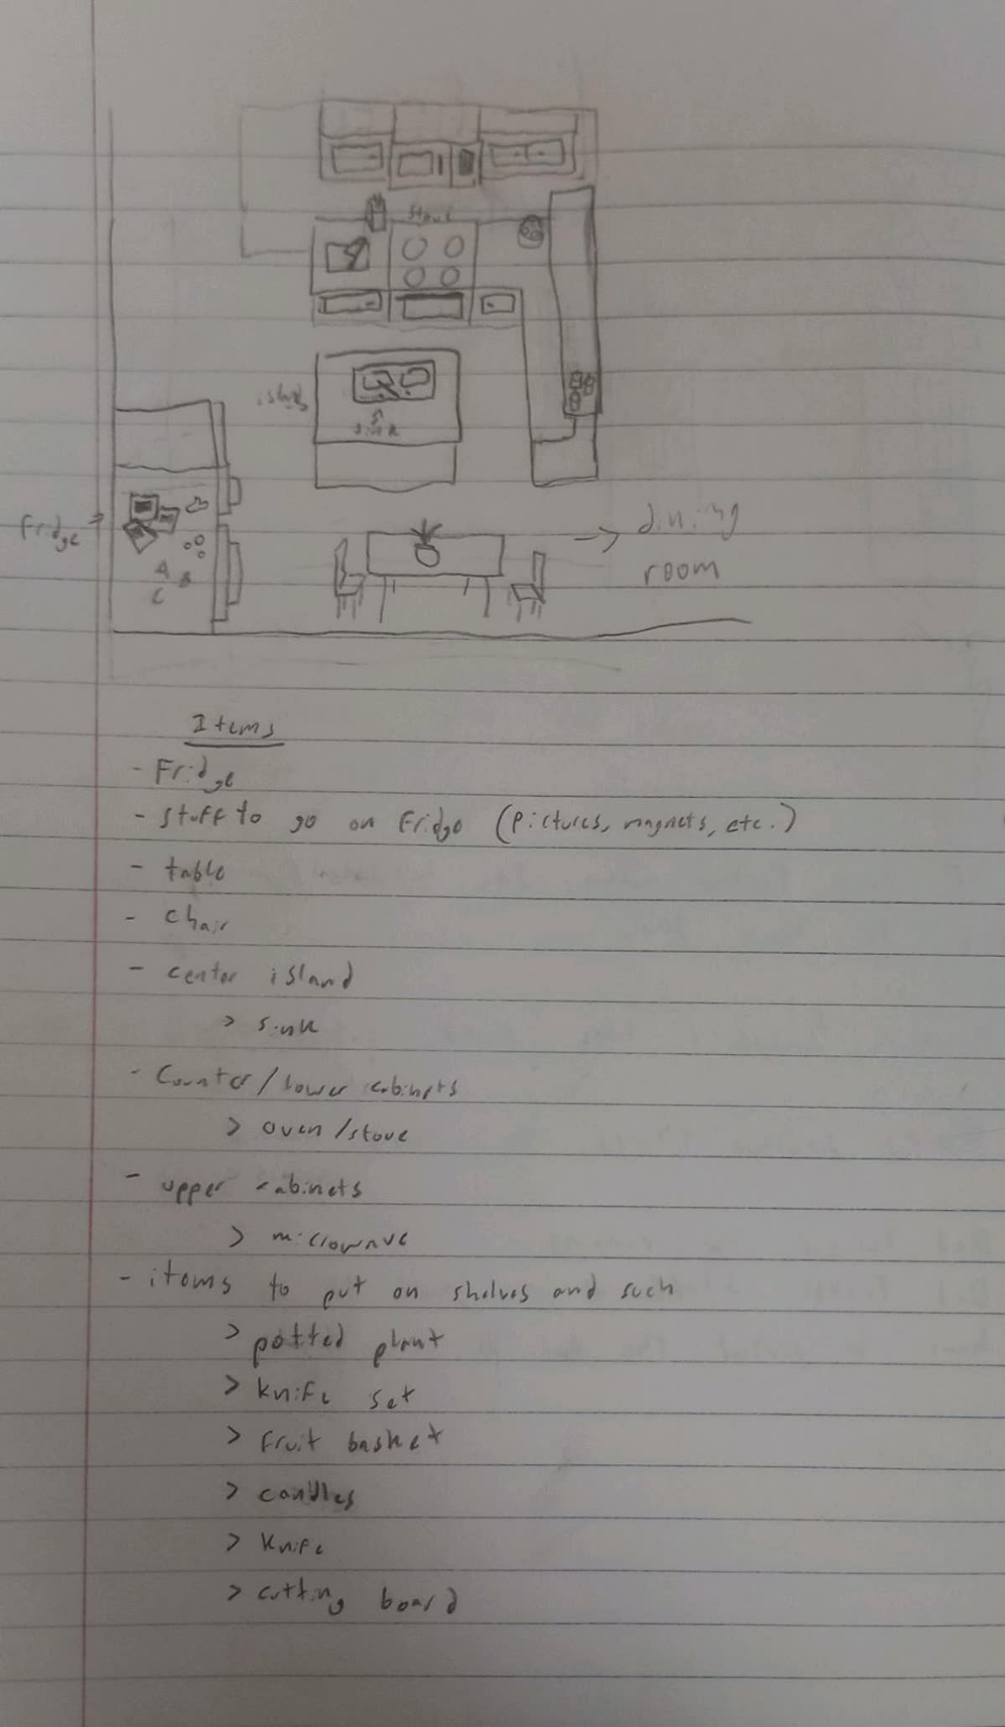
- The player character is 4’ 6’’
- An 8px by 8px square is 1’6’’ by 1’6’’
- Look at the art i’ve already made for the basement/michaels room for reference on the art style

Create art guides
Description:
Create a guide in this format for different rooms of the house. Rooms we still need are:
- Attic (Alex Lee)
- Upstairs bathroom
- Upstairs hallway
- Gus’s room (Sam)
- Gus’s closet (Sam)
- Mid level bathroom
- Living room
- Office
- Dining room
- Mid level Hallway
- Boiler room (Alex Lee)
- Pool/Bar area
- Garage (Alex Lee)
- Front Yard
- Backyard
- Treehouse
Notes:
- Use the same format as the kitchen

Future artifacts
- Create Gameobjects for assets
- Decorate rooms

